SQL Querry Sheet (Toman Bike Shop Sales Dashboard)

with cte as (

select * from bike_share_yr_0

union all

select * from bike_share_yr_1)

select

dteday,

season,

a.yr,

weekday,

hr,

rider_type,

riders,

price,

COGS,

riders*price as revenue,

riders*price -COGS*riders as profit

from cte a

left join cost_table b

on a.yr = b.yr

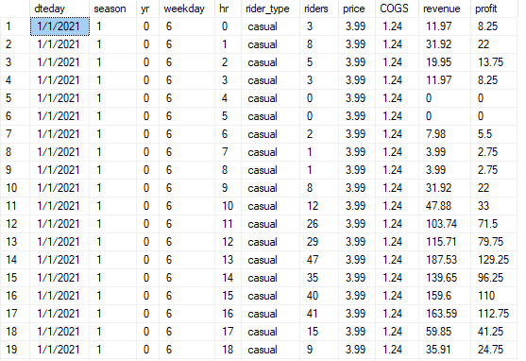

The table displays hourly sales data across a week, with higher earnings in midday and early evening hours, particularly around 10 to 15 hours, suggesting these are the most profitable times.

Days like Wednesday and Friday show notably higher sales, indicating variable profitability across the week.